

PHYSICS 11

ELECTRICITY TEST

STUDENT NAME

- What is the major reason why metals are good conductors of heat and electricity and insulators are poor conductors?

(2)

- An electroscope pointer diverges when a positively charged rod is brought close to the metal plate of the electroscope.

- Draw a diagram of the electroscope and on it show the distribution of charge on the electroscope and the rod.

(2)
- If without changing the above situation you touch the metal plate with your finger, (thus earthing it), in which direction will electrons flow In to or out of our body?

(1)

- Clare took 5 minutes to dry her hair with a DC hair dryer. The current the hairdryer was drawing during this period was 4.0 A.

- How much charge has passed through the hair dryer?

(2)

- If the mains voltage is 150V DC what is the resistance of the hair dryer?

(2)

- What is the power rating of the hairdryer?

(2)

- How much work was done by the hairdryer in drying Clare’s hair?

(2)

- An electrician sets up a power circuit in a room of a new house. It has 3 power points with switches. The power points are to be used to run a study lamp with a 60W bulb, a TV set rated at 400W and an electric heater rated at 600W. This house runs off a mains voltage of 240V.

(a) Draw a circuit diagram of the room using the following as symbols for the devices.:

heater TV lamp

active

Neutral

Earth

(4)

(b) If all three devices are being used at the same time. How much energy is being used per second in the room?

(2)

(C)
What is the current drawn by each of the devices? (work it out in the spaces provided)

HEATER | TELEVISION | LAMP

(3)
(d)
What is the resistance of each of the devices

HEATER | TV | LAMP

(3)
- If by mistake the electrician only placed a 4A fuse in this circuit would it blow when all three devices were operating? (You must present evidence for your answer).

(2)
- Use the calculated resistance’s of each of the devices to find the total resistance of the circuit and use this to prove that the total current drawn when all three devices are in use is equal to the sum of the individual currents passing through them.

(3)
- Dimmer switches are used to vary the intensity of a light. Draw a circuit diagram using one dimmer switch and one globe to show how these work. Use the correct symbols.

Active

Neutral

(2)

- How much will it cost to run a 100W light bulb for a day if Western Power charges 14.2 cents per kWh?

(3)

7

RESISTIVITY AND EARTHING

The performance of an electrical earthing system is directly dependent upon the ability of the earth to absorb the flow of electricity from the earthing conductor .Variations in earth resistivity have considerable influence on most earthing systems, effecting grid performance ,the ground potential rise and the step surface voltages.
The impedance of the body and the foot-to-ground impedance can be considered as the resistance encounted by the current.
By law all homes must have an earthing system which can efficiently carry current from an electrical fault to the ground through the earth wire. In days gone by this earth wire was usually connected to the outside water pipe as it was made of metal. With the advent of plastic water pipes builder must now sink an earthing plate in the ground to dissipate the current . The size of the plate is controlled by the condition of the soil which controls the resistivity.
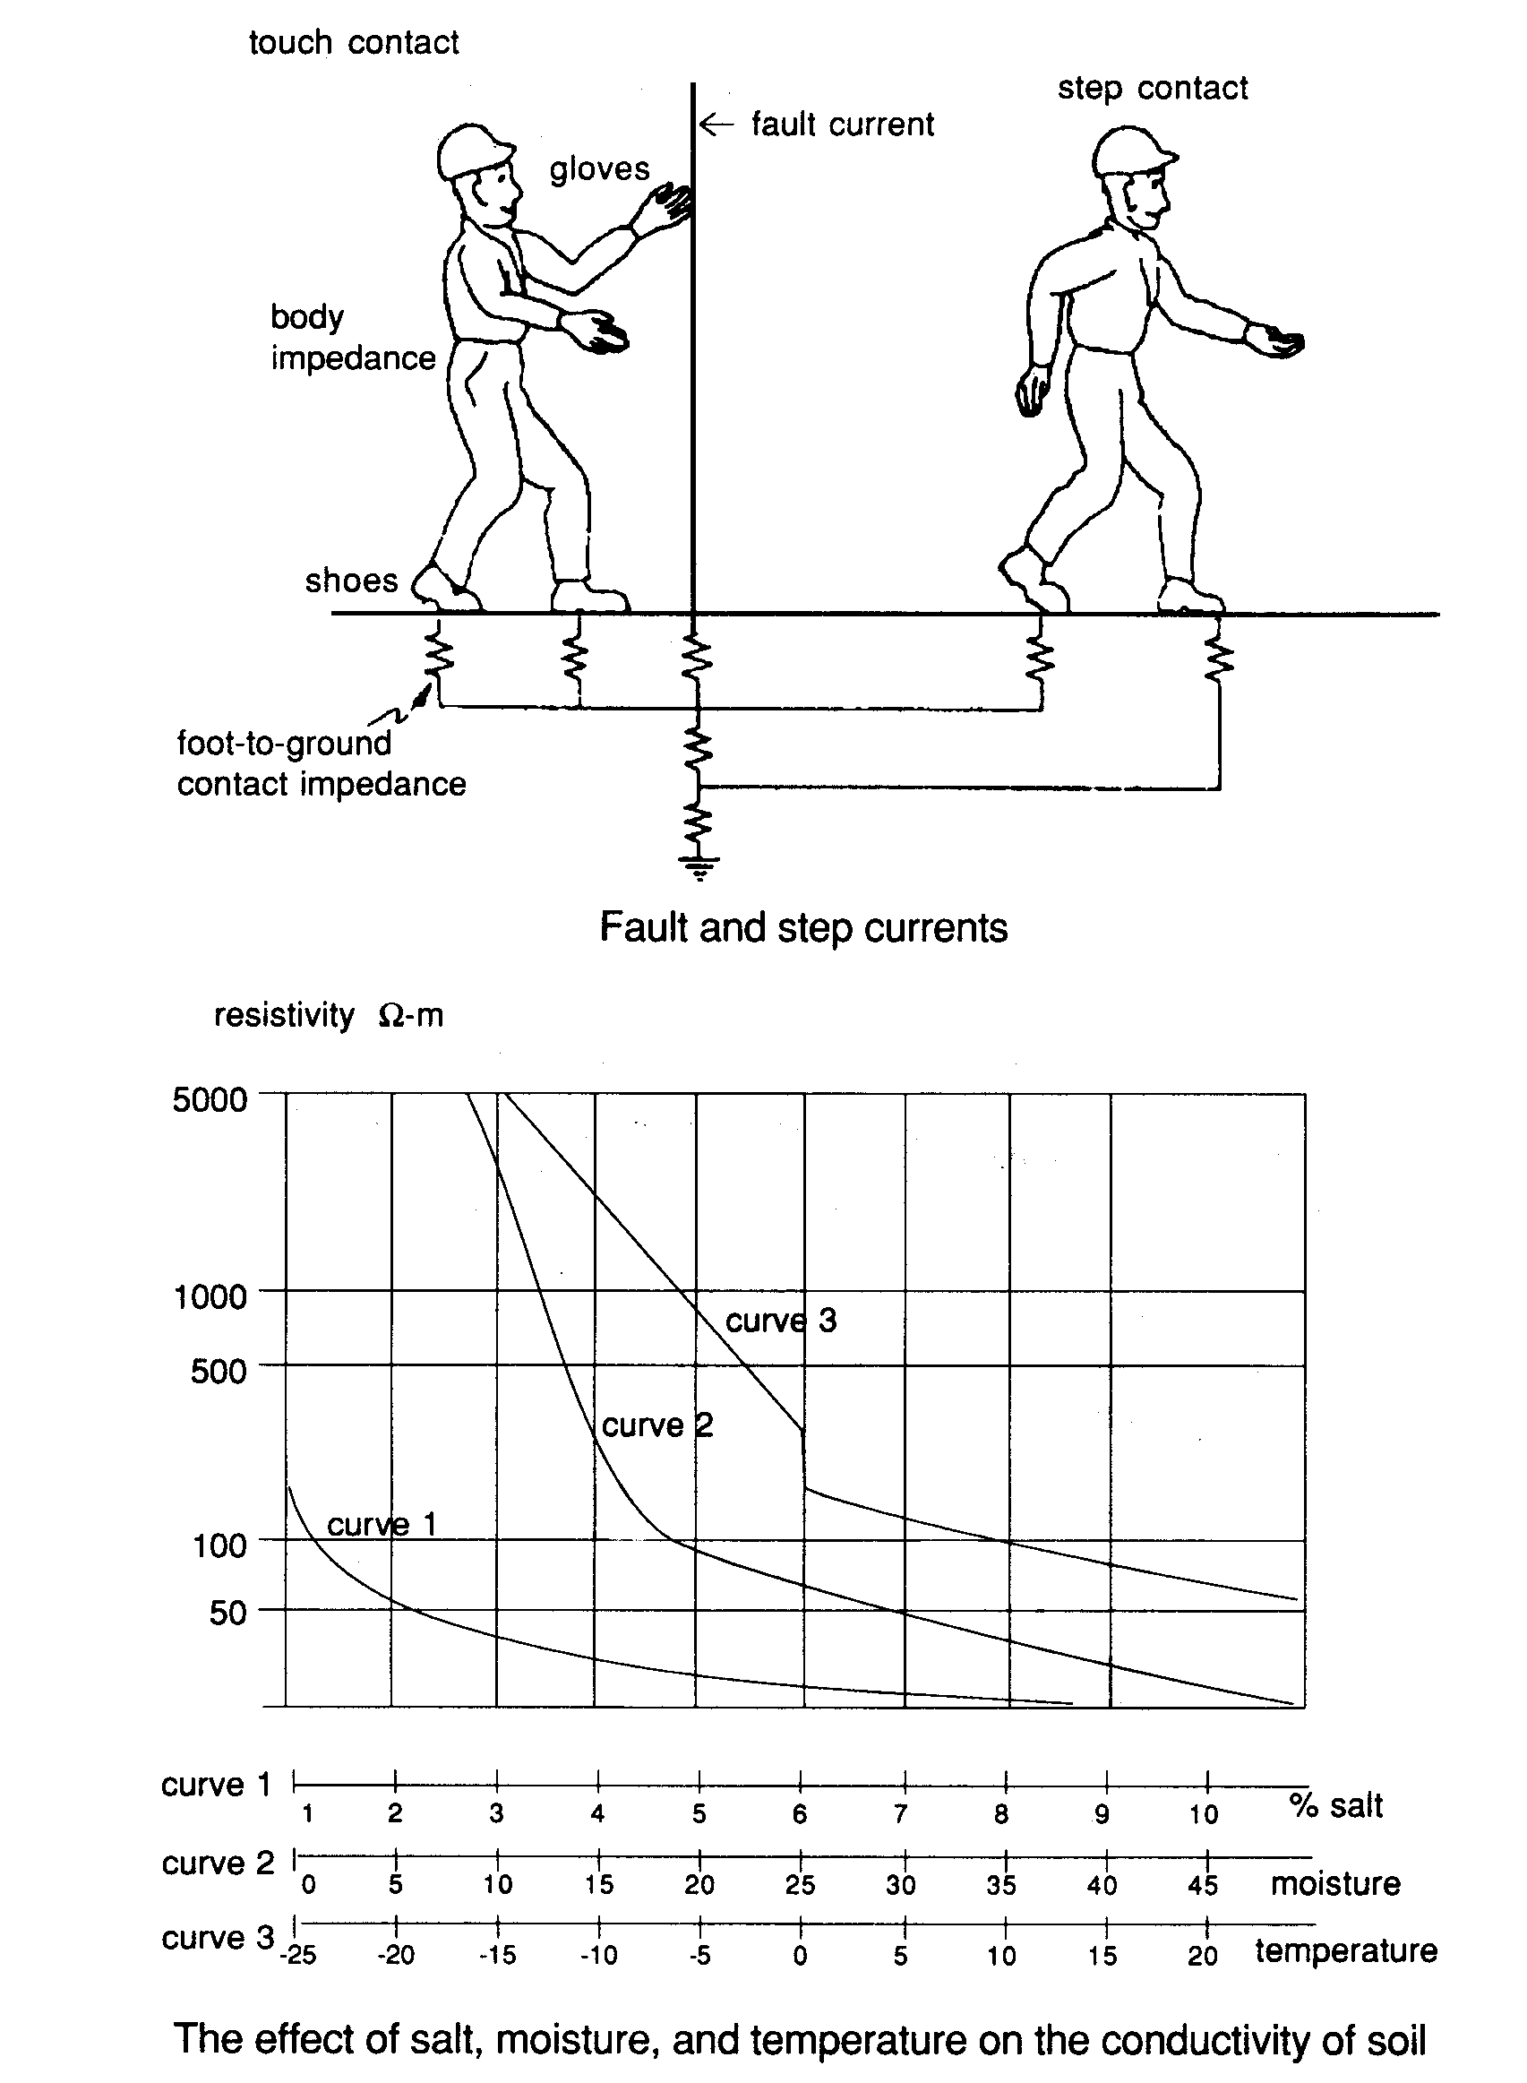

- Why would the information in the graph be useful for an electrician or a home
builder?

(2)
- Why does the resistivity of the soil decrease dramatically with an increase in the salt content of the soil?

(2)

- Which has the greatest effect on the resistivity – moisture or temperature? Explain your answer.

(2)
- Look at the picture of the man walking away from the earth wire carrying the fault current, which of his legs is at the greatest electrical potential (magnitude only ignoring if it is positive or negative). His LEFT or RIGHT?

(1)
- in which direction will conventional current flow through the man .UP or DOWN his left leg?

(1)
- Use the words high or low for each of the three variables to give the soil it’s lowest resistivity.

(3)

END OF PAPER

